Stability Analysis of the Slope above the Road
Project | SSA user manual tutorial case
Prepared by | ABC Engineering Consultants, J. Doe
Date | 2026-11-01
Software | SSA Slope Stability Analysis (web edition) v2.10.2 (2026-11-01), https://cychen59.github.io/ssa-slope-stability/
Method | simplified Janbu method, judged by uncorrected Fs
Notes | Tutorial case; parameters are assumed values.

1. Method of analysis
Slope stability is analysed by the two-dimensional limit equilibrium method of slices. The critical slip surface of arbitrary shape is searched by dynamic programming (DP) (Nakamura and Kubota, 1987; Baker, 1980), with entry and exit points determined by the computation. Pore pressure is obtained from the water table, u = γw·hw, and earthquake loading by the pseudo-static method with horizontal and vertical coefficients kh and kv.
The factor of safety is computed by the simplified Janbu method, which satisfies force equilibrium only; the correction factor f0 follows the selected formula.

2. Input data

2.1 Geometry
Line | Points (x, z) (m)
Ground surface | (0.00, 10.00) (9.07, 10.00) (10.50, 12.50) (15.00, 12.50) (35.00, 22.50) (50.00, 24.00) (70.00, 25.00)
Top of Weathered rock | (0.00, 6.00) (15.00, 7.50) (35.00, 16.00) (70.00, 19.00)
Top of Bedrock | (0.00, 2.00) (35.00, 9.00) (70.00, 12.00)
Water table | (0.00, 7.00) (15.00, 8.50) (35.00, 17.00) (70.00, 21.00)
Model base elevation | 0.00 m

2.2 Soil properties
Layer | γ (kN/m³) | γsat (kN/m³) | c′ (kPa) | φ′ (°) | Pore pressure | Bedrock
Colluvium | 18.00 | 20.00 | 5.00 | 28.0 | water table | —
Weathered rock | 21.00 | 22.00 | 30.00 | 32.0 | water table | —
Bedrock | 24.00 | 24.00 | 200.00 | 40.0 | — | yes

2.3 Surface loads
Name | Type | Position x (m) | Magnitude | Seismic inertia
Traffic | Distributed | 36.00 – 44.00 | 10.00 kPa | no

2.4 Reinforcement (passive method)
No. | Type | Head (x, z) | θ (°) | L (m) | Sh (m) | Capacities
1 | Soil nail | 16.00, 13.00 | 15.0 | 9.00 | 1.50 | Tt 180.00, q 40.00, Tf 150.00
2 | Soil nail | 18.57, 14.29 | 15.0 | 9.00 | 1.50 | Tt 180.00, q 40.00, Tf 150.00
3 | Soil nail | 21.14, 15.57 | 15.0 | 9.00 | 1.50 | Tt 180.00, q 40.00, Tf 150.00
4 | Soil nail | 23.71, 16.86 | 15.0 | 9.00 | 1.50 | Tt 180.00, q 40.00, Tf 150.00
5 | Soil nail | 26.29, 18.14 | 15.0 | 9.00 | 1.50 | Tt 180.00, q 40.00, Tf 150.00
6 | Soil nail | 28.86, 19.43 | 15.0 | 9.00 | 1.50 | Tt 180.00, q 40.00, Tf 150.00
7 | Soil nail | 31.43, 20.71 | 15.0 | 9.00 | 1.50 | Tt 180.00, q 40.00, Tf 150.00
8 | Soil nail | 34.00, 22.00 | 15.0 | 9.00 | 1.50 | Tt 180.00, q 40.00, Tf 150.00

2.5 Retaining walls
Name | Type | γ (kN/m³) | Dimensions | Vertices (x, z) (m)
Gravity wall at the toe | Gravity | 23.50 | H 3.50, B 3.00, b 1.00 m；toe at (8.50, 9.00) | (8.50, 9.00) (11.50, 9.00) (11.50, 12.50) (10.50, 12.50)

2.6 Analysis settings
Seismic kh / kv | 0.000 / 0.000
Unit weight of water γw | 9.81 kN/m³
Inclined water table correction | no
Tension crack | not considered
Search grid (lines × nodes) | 60 × 80, slices per segment 4
Minimum slip depth | 1.00 m
Concavity / no boundary crossing | ✓ / ✓
Tolerance ΔF / max iterations | 0.0001 / 30
Correction factor f0 | f0 = (50d/L)^0.03
Required Fs (current model) | 1.50

3. External stability of retaining walls
External stability treats the wall and the soil above its base slab as a rigid body and checks sliding, overturning, the position of the resultant and bearing capacity from force equilibrium. For gravity walls the active earth pressure on the back is computed by the Coulomb formula; for cantilever and counterfort walls it acts on a vertical virtual back through the heel, by the Rankine formula (δ = β), with the soil above the base slab counted in the wall weight. In seismic cases the earth pressure follows the Mononobe–Okabe formula and the inertia kh·W of the wall and soil is included. Water pressure behind the wall and uplift on the base follow the water table; bearing capacity is computed by the Meyerhof formula (effective width B′ = B − 2e, with depth and load inclination factors).
Required values follow “Soil and Water Conservation Technical Regulations Art. 120”: sliding Fs ≥ 1.5 (seismic 1.2), overturning Fs ≥ 2.0 (seismic 1.5), bearing Fs ≥ 3.0 (seismic 3.0); the resultant must lie in the middle third of the base on soil (e ≤ B/6) and in the middle half on rock (e ≤ B/4).

3.1 W1 Gravity wall at the toe (Gravity)
Item | Normal | Heavy rain | Earthquake（kh 0.15）
Sliding Fs | 4.13 ≥ 1.5 OK | 2.77 ≥ 1.5 OK | 1.35 ≥ 1.2 OK
Overturning Fs | 22.85 ≥ 2.0 OK | 5.29 ≥ 2.0 OK | 5.47 ≥ 1.5 OK
Eccentricity |e| (m) | 0.319 ≤ 0.500 OK | 0.346 ≤ 0.500 OK | 0.074 ≤ 0.500 OK
qmax / qmin (kPa) | 95.85 / 21.19 | 82.36 / 15.00 | 68.62 / 50.96
Bearing | Fs 6.44 ≥ 3.0 OK | Fs 3.72 ≥ 3.0 OK | Fs 5.21 ≥ 3.0 OK
Result | OK | OK | OK
Backfill / foundation φ′ | Colluvium 28.0° / Colluvium 28.0° | Colluvium 28.0° / Colluvium 28.0° | Colluvium 28.0° / Colluvium 28.0°
β / δ / K | 0.0° / 18.7° / 0.3213 | 0.0° / 18.7° / 0.3213 | 0.0° / 18.7° / 0.4362 (M–O)
h (m) / q (kPa) | 3.50 / 0.00 | 3.50 / 0.00 | 3.50 / 0.00
Pa (kN/m) / height (m) | 18.36 / 0.84 | 16.69 / 0.89 | 30.30 / 0.93
Pw / U (kN/m) | 0.00 / 0.00 | 6.49 / 29.43 | 0.00 / 0.00
ΣW / ΣV / ΣH (kN/m) | 169.67 / 175.55 / 17.40 | 170.12 / 146.03 / 22.30 | 169.67 / 179.37 / 54.16
Mr / Mo (kN/m·m) | 333.94 / 14.61 | 332.40 / 62.84 | 345.40 / 63.09
μ / Pp (kN/m) | 0.338 / 12.46 | 0.338 / 12.46 | 0.338 / 12.46
qu (kPa) / B′ (m) | 617.12 / 2.36 | 306.38 / 2.31 | 357.27 / 2.85

Moments are about the toe; ΣH includes the horizontal earth thrust, water pressure and seismic inertia, and ΣV is net of uplift.

4. Results (current model)
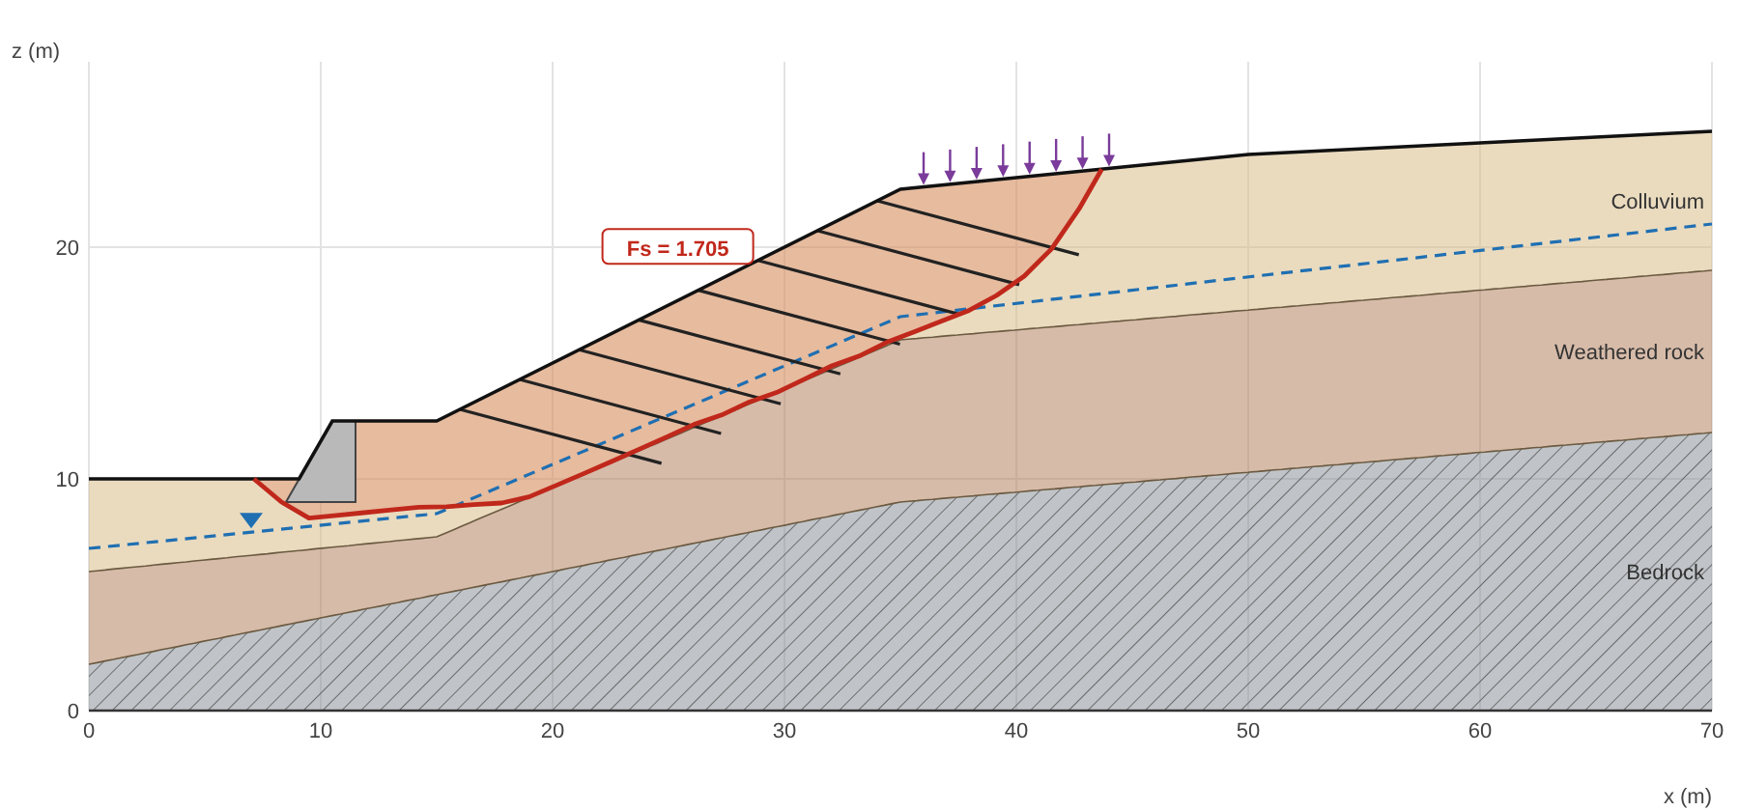
Figure 1 Cross-section and critical slip surface (search)
Factor of safety for judgement | 1.705（simplified Janbu, uncorrected）
Required Fs / result | 1.50 / OK
Simplified Janbu Fs / f0·Fs | 1.705 / 1.800（f0 = 1.056）
Spencer Fs (λ) | 1.848（0.327）
Morgenstern–Price Fs (λ) | 1.786（0.450）
Sliding mass area / max depth | 172.2 m²/m / 6.38 m
Toe exit / crest entry (x, z) | (7.12, 10.00) / (43.68, 23.37)
Fs without reinforcement | 1.263
Fs without loads | 1.753

Critical slip surface (x, z):(7.12, 10.00) (8.31, 9.00) (9.49, 8.31) (10.68, 8.43) (11.86, 8.54) (13.05, 8.66) (14.24, 8.77) (15.42, 8.80) (16.61, 8.89) (17.80, 8.96) (18.98, 9.23) (20.17, 9.73) (21.36, 10.23) (22.54, 10.75) (23.73, 11.27) (24.92, 11.81) (26.10, 12.35) (27.29, 12.76) (28.47, 13.31) (29.66, 13.72) (30.85, 14.30) (32.03, 14.88) (33.22, 15.30) (34.41, 15.89) (35.59, 16.34) (36.78, 16.81) (37.97, 17.27) (39.15, 17.92) (40.34, 18.75) (41.53, 19.93) (42.71, 21.66) (43.68, 23.37)
Member | Crossing (x, z) | Le (m) | T (kN/m) | Governed by
1 Soil nail | 23.25, 11.06 | 1.50 | 39.97 | pullout
2 Soil nail | 25.99, 12.30 | 1.32 | 35.08 | pullout
3 Soil nail | 28.95, 13.48 | 0.92 | 24.50 | pullout
4 Soil nail | 31.71, 14.72 | 0.72 | 19.31 | pullout
5 Soil nail | 34.52, 15.93 | 0.48 | 12.76 | pullout
6 Soil nail | 37.54, 17.10 | 0.01 | 0.34 | pullout
7 Soil nail | 39.90, 18.44 | 0.23 | 6.15 | pullout
8 Soil nail | 41.55, 19.98 | 1.18 | 31.43 | pullout

4.1 Slice details
124 slices in total; every 3th slice is listed below. The full table can be copied as CSV from “Slice details” on the web page.
x (m) | b (m) | z (m) | α (°) | W (kN/m) | u (kPa) | c′ (kPa) | φ′ (°) | Layer | R (kN/m) | D (kN/m)
7.27 | 0.30 | 9.87 | -40.2 | 0.67 | 0.00 | 5.00 | 28.0 | Colluvium | 4.27 | -0.56
8.16 | 0.30 | 9.12 | -40.2 | 4.68 | 0.00 | 5.00 | 28.0 | Colluvium | 9.22 | -3.94
9.05 | 0.30 | 8.57 | -30.2 | 9.21 | 0.00 | 5.00 | 28.0 | Colluvium | 10.45 | -5.37
9.94 | 0.30 | 8.35 | 5.8 | 20.98 | 0.00 | 5.00 | 28.0 | Colluvium | 12.38 | 2.13
10.83 | 0.30 | 8.44 | 5.6 | 27.37 | 0.00 | 5.00 | 28.0 | Colluvium | 15.71 | 2.67
11.72 | 0.30 | 8.53 | 5.6 | 21.20 | 0.00 | 5.00 | 28.0 | Colluvium | 12.50 | 2.06
12.61 | 0.30 | 8.62 | 5.6 | 20.74 | 0.00 | 5.00 | 28.0 | Colluvium | 12.26 | 2.02
13.50 | 0.30 | 8.70 | 5.6 | 20.28 | 0.00 | 5.00 | 28.0 | Colluvium | 12.02 | 1.97
14.39 | 0.30 | 8.78 | 1.1 | 19.88 | 0.00 | 5.00 | 28.0 | Colluvium | 11.98 | 0.39
15.28 | 0.30 | 8.80 | 1.1 | 20.52 | 0.00 | 5.00 | 28.0 | Colluvium | 12.32 | 0.41
16.17 | 0.30 | 8.86 | 4.6 | 22.64 | 1.35 | 5.00 | 28.0 | Colluvium | 13.07 | 1.82
17.06 | 0.30 | 8.92 | 3.2 | 24.88 | 4.46 | 5.00 | 28.0 | Colluvium | 13.81 | 1.41
17.94 | 0.30 | 8.99 | 12.7 | 27.03 | 7.43 | 5.00 | 28.0 | Colluvium | 14.42 | 6.11
18.83 | 0.30 | 9.20 | 12.7 | 28.43 | 9.17 | 5.00 | 28.0 | Colluvium | 14.88 | 6.42
19.72 | 0.30 | 9.54 | 22.7 | 28.99 | 9.50 | 5.00 | 28.0 | Colluvium | 16.01 | 12.14
20.61 | 0.30 | 9.92 | 23.1 | 29.36 | 9.52 | 5.00 | 28.0 | Colluvium | 16.27 | 12.53
21.50 | 0.30 | 10.30 | 23.5 | 29.70 | 9.50 | 5.00 | 28.0 | Colluvium | 16.52 | 12.91
22.39 | 0.30 | 10.68 | 23.5 | 30.01 | 9.41 | 5.00 | 28.0 | Colluvium | 16.70 | 13.04
23.28 | 0.30 | 11.08 | 23.9 | 30.28 | 9.27 | 5.00 | 28.0 | Colluvium | 59.66 | 13.40
24.17 | 0.30 | 11.47 | 24.2 | 30.52 | 9.08 | 5.00 | 28.0 | Colluvium | 17.17 | 13.75
25.06 | 0.30 | 11.87 | 24.6 | 30.74 | 8.85 | 5.00 | 28.0 | Colluvium | 17.40 | 14.09
25.95 | 0.30 | 12.28 | 24.6 | 30.92 | 8.56 | 5.00 | 28.0 | Colluvium | 55.00 | 14.17
26.84 | 0.30 | 12.60 | 18.9 | 31.61 | 9.11 | 5.00 | 28.0 | Colluvium | 17.01 | 10.81
27.73 | 0.30 | 12.97 | 25.2 | 32.07 | 9.28 | 5.00 | 28.0 | Colluvium | 18.18 | 15.07
28.62 | 0.30 | 13.37 | 19.1 | 32.29 | 9.07 | 5.00 | 28.0 | Colluvium | 17.41 | 11.18
29.51 | 0.30 | 13.67 | 19.1 | 33.07 | 9.76 | 5.00 | 28.0 | Colluvium | 17.71 | 11.44
30.40 | 0.30 | 14.08 | 25.7 | 33.24 | 9.46 | 5.00 | 28.0 | Colluvium | 18.93 | 16.02
31.29 | 0.30 | 14.51 | 26.1 | 33.28 | 8.92 | 5.00 | 28.0 | Colluvium | 19.11 | 16.30
32.18 | 0.30 | 14.93 | 19.5 | 33.41 | 8.56 | 5.00 | 28.0 | Colluvium | 18.14 | 11.83
33.07 | 0.30 | 15.25 | 19.5 | 34.14 | 9.18 | 5.00 | 28.0 | Colluvium | 18.43 | 12.08
33.96 | 0.30 | 15.67 | 26.6 | 34.22 | 8.72 | 5.00 | 28.0 | Colluvium | 19.81 | 17.17
34.85 | 0.30 | 16.06 | 20.6 | 34.51 | 8.60 | 5.00 | 28.0 | Colluvium | 18.87 | 12.95
35.74 | 0.30 | 16.40 | 21.5 | 33.39 | 6.75 | 5.00 | 28.0 | Colluvium | 18.69 | 13.14
36.63 | 0.30 | 16.75 | 21.5 | 31.85 | 4.31 | 5.00 | 28.0 | Colluvium | 19.87 | 13.70
37.52 | 0.30 | 17.10 | 21.5 | 30.30 | 1.87 | 5.00 | 28.0 | Colluvium | 19.79 | 13.11
38.41 | 0.30 | 17.52 | 28.6 | 28.43 | 0.00 | 5.00 | 28.0 | Colluvium | 20.16 | 17.12
39.30 | 0.30 | 18.02 | 34.9 | 26.20 | 0.00 | 5.00 | 28.0 | Colluvium | 20.74 | 20.33
40.19 | 0.30 | 18.64 | 34.9 | 23.36 | 0.00 | 5.00 | 28.0 | Colluvium | 18.90 | 18.35
41.08 | 0.30 | 19.49 | 45.0 | 19.33 | 0.00 | 5.00 | 28.0 | Colluvium | 20.33 | 22.29
41.97 | 0.30 | 20.58 | 55.5 | 13.97 | 0.00 | 5.00 | 28.0 | Colluvium | 22.49 | 24.64
42.86 | 0.30 | 21.92 | 60.4 | 7.29 | 0.00 | 5.00 | 28.0 | Colluvium | 18.36 | 18.06
43.75 | 0.08 | 23.30 | 60.4 | 0.10 | 0.00 | 5.00 | 28.0 | Colluvium | 5.38 | 5.39

5. Multi-case check
Water table, seismic coefficients and required factor of safety of each case are listed below; required values default to Art. 73 of the Soil and Water Conservation Technical Regulations (permanent slopes) and may be changed by the analyst according to the applicable code. The critical surface is searched separately for each case.
Case | Water table | kh | kv | Loads / reinf. | Fs | Required | Result
Normal | Water table of the profile | 0.000 | 0.000 | ✓ / ✓ | 1.705 | 1.50 | OK
Heavy rain | Water table raised by Δh 2.00 m | 0.000 | 0.000 | ✓ / ✓ | 1.414 | 1.20 | OK
Earthquake | Water table of the profile | 0.150 | 0.000 | ✓ / ✓ | 1.187 | 1.10 | OK

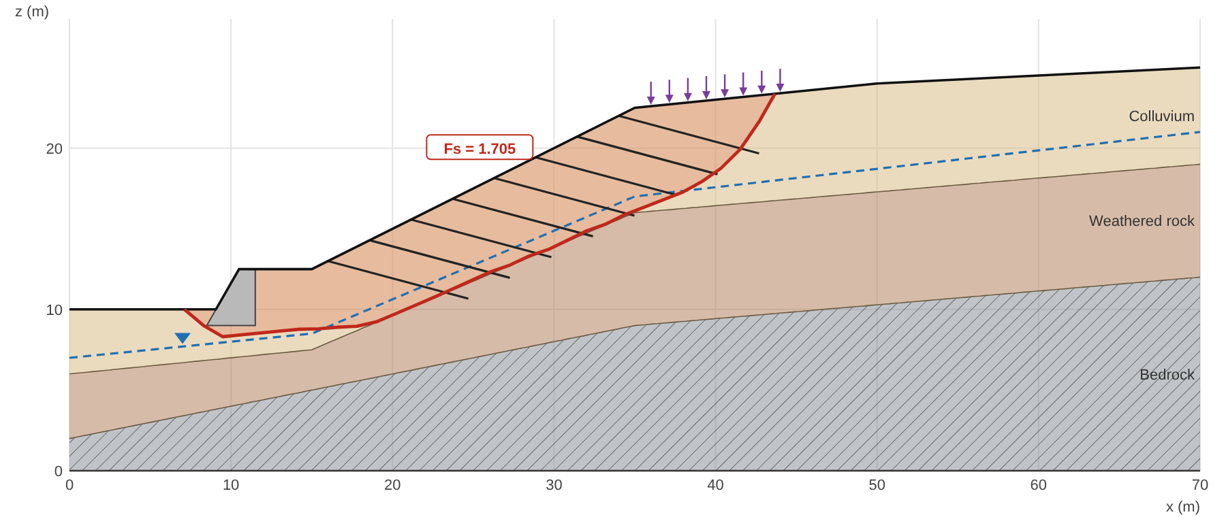
Figure 2 Critical slip surface, case “Normal”
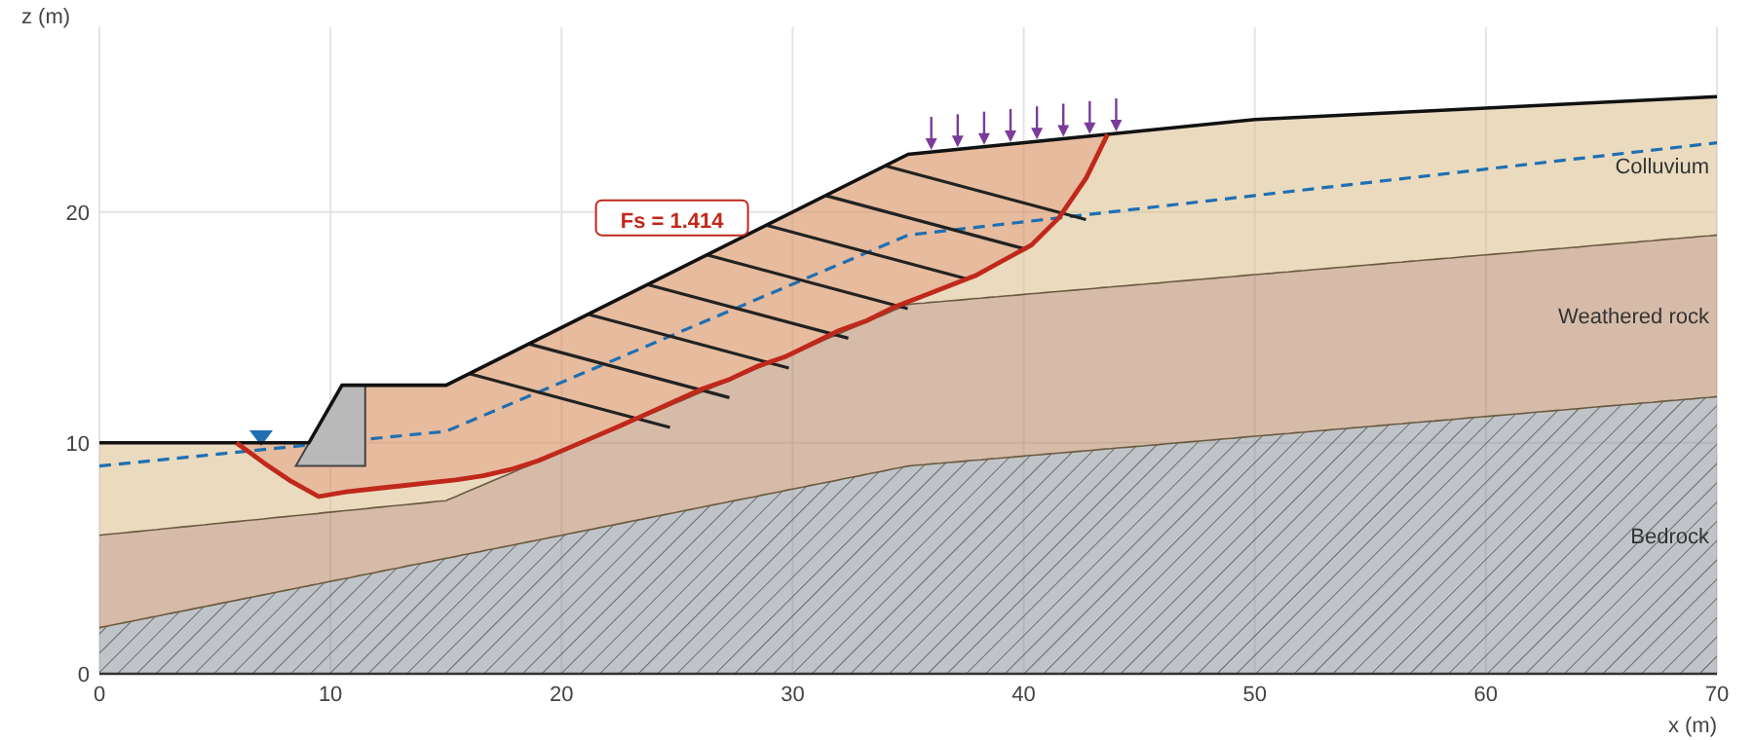
Figure 3 Critical slip surface, case “Heavy rain”
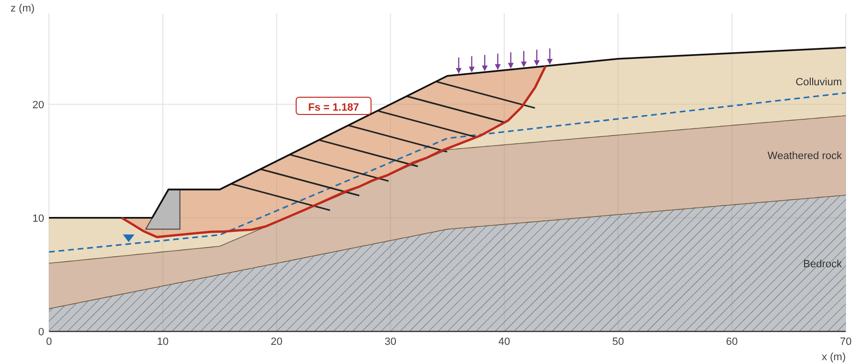
Figure 4 Critical slip surface, case “Earthquake”

6. Notes
This is a two-dimensional plane-strain limit equilibrium analysis; matric suction is not considered, pore pressure comes from water lines (hydrostatic) or ru without seepage analysis, and ponded water is treated as hydrostatic. Reinforcement carries tension only. External wall stability treats the wall as a rigid body and the earth pressure behind it includes uniform loads only; the structural strength of the stem and base slab must be checked separately. Results are for reference; engineering judgement and design remain the responsibility of qualified professionals based on site investigation and the applicable codes.
References: Chen, Fujita and Tsutsumi (2014), J. Chinese Soil and Water Conservation 45(4), 243-256; Nakamura and Kubota (1987), PWRI Technical Memorandum 2425; Spencer (1967); Morgenstern and Price (1965); Janbu (1973); Baker (1980); Coulomb (1776); Rankine (1857); Okabe (1926); Mononobe and Matsuo (1929); Meyerhof (1963).
Generated by SSA v2.10.2 (2026-11-01). The verification report of this version can be run and downloaded on the Help tab.

